Nunit and Moq
Name: NALLANI LOKAKALYAN
Registered Mail: 2300030853cseh1@gmail.com

Exercise 1:
Main.java:
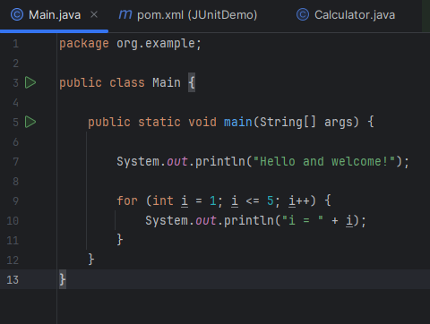Pom.xml: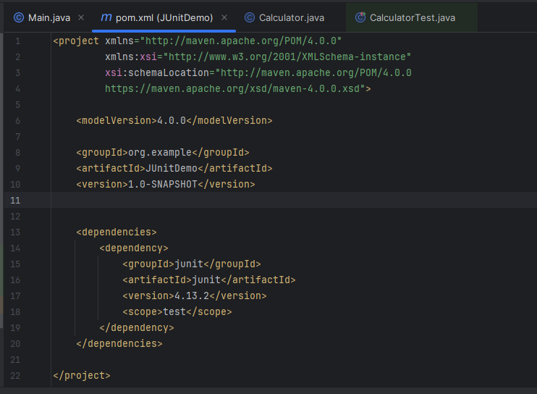
Calculator.java: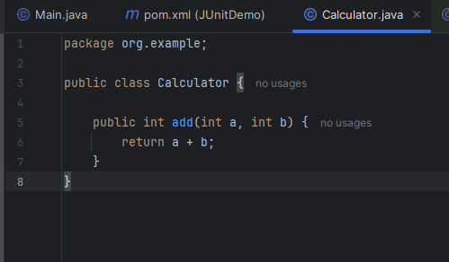
CalculatorTest.java:
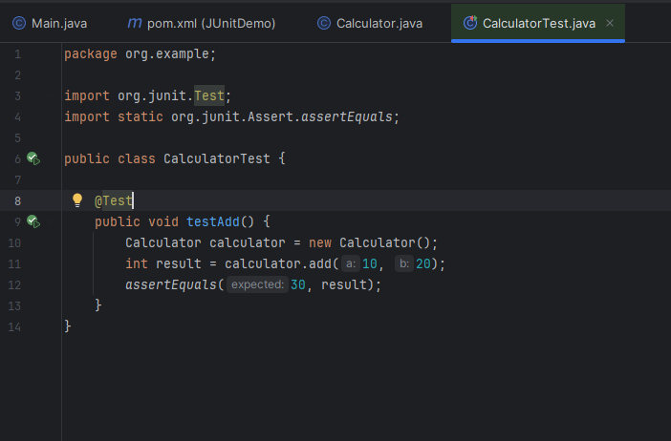

Output Screenshot:
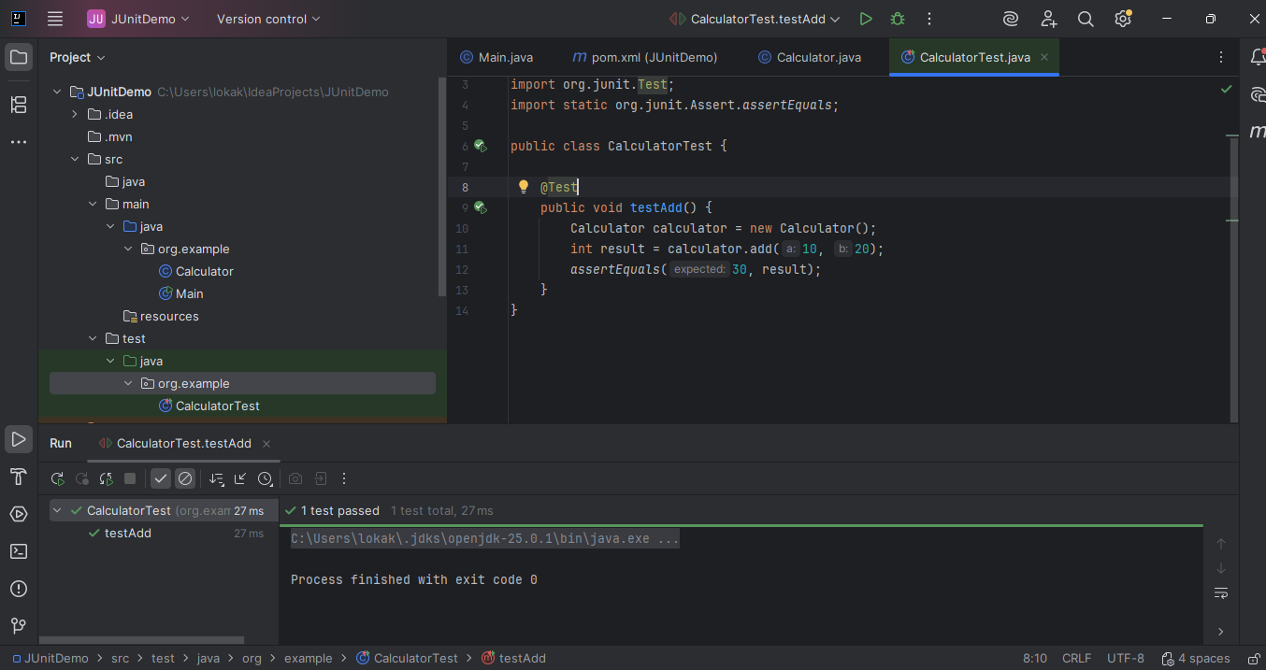

Exercise 3: Assertions in JUnit:

Main.java: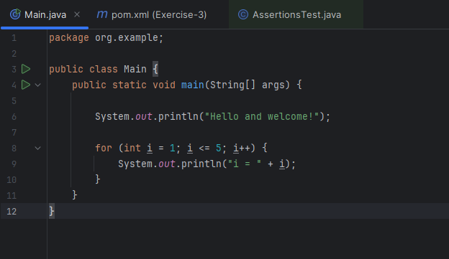Pom.xml: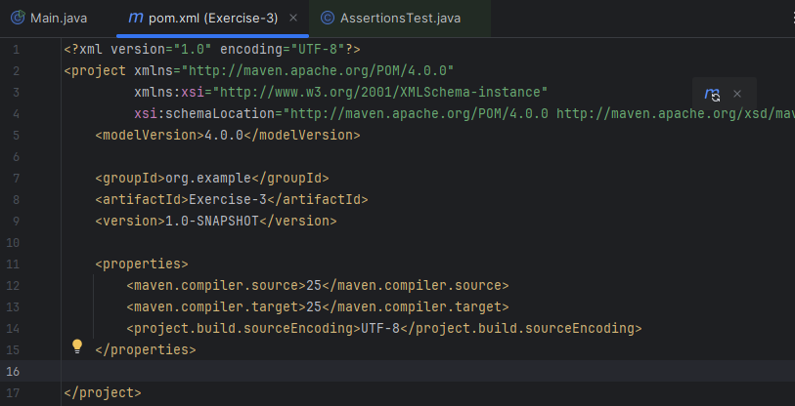

Assertions.java: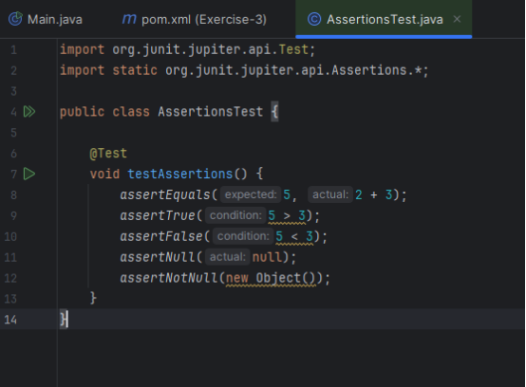

Output Screenshot:
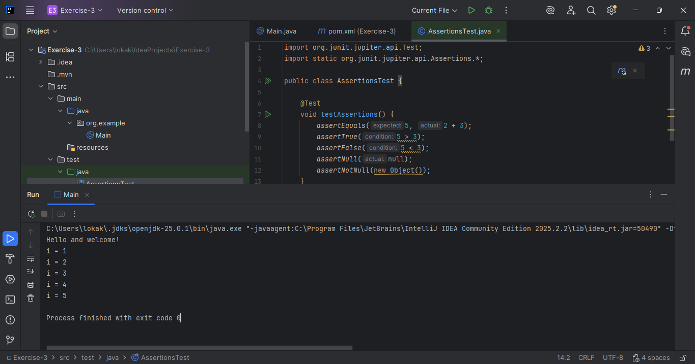

Exercise 4: Arrange-Act-Assert (AAA) Pattern, Test Fixtures, Setup and Teardown Methods in JUnit:
Main.java:
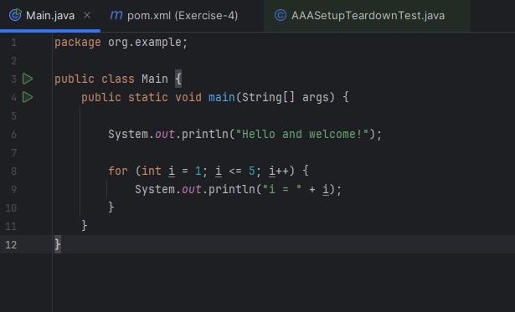
Pom.xml: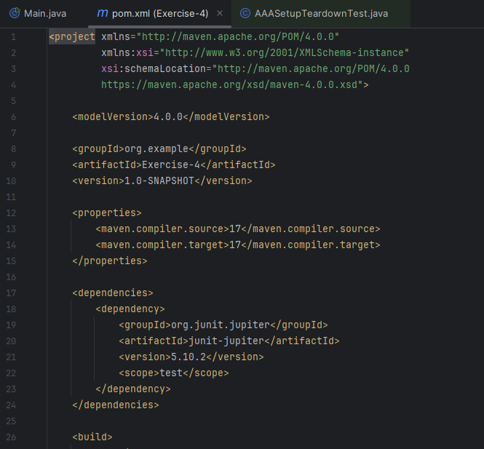
AAASetupTeardownTest.java:
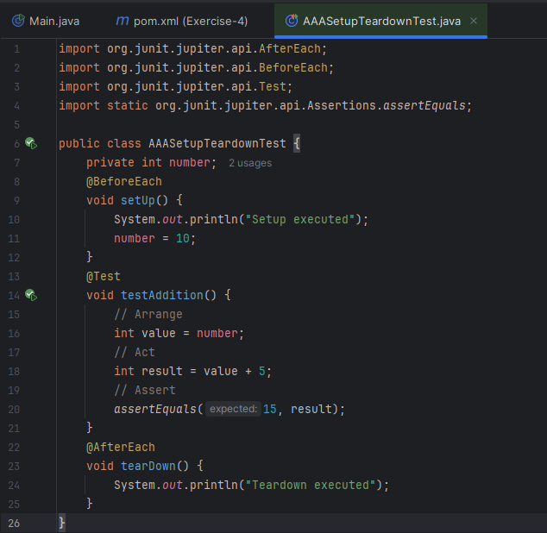

Output Screenshot:
